Nepal College of Information Technology
Unit Test
Spring 2011
Program : BE IT/ELX Time : 2 hrs
Semester : Fall (II) FM : 70
Subject : Engineering Math-II PM : 35

- Candidates are requested to give their answer as far as practicable in their own words.
- The figure in the margin indicates the full marks
- Attempt ALL question

1. a) Solve:
(x+y)² y' = a² [7]
b) Solve:
2xy dy = (x²+y²) dx, y(1) = 2 [8]
2. a) Solve 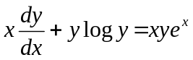 [7]
b) Solve y" - 3y' +2y = 4x +e^{x} [8]
3. Solve the following differential equation
a) y" - y' - 2y = 3e^{2x} y(0) = 0, y'(0) = -2 [8]
b) y" + 2y' +y = 4e^{-x} logx [7]
4. a) State and prove Enler's theorem on homogeneous function of two independent variables and if
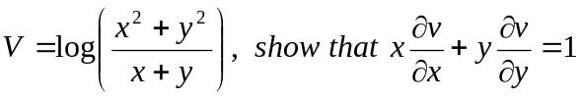 [8]
b) Prove that of all the rectangular parallelopipeds of given surface, cube has the maximum volume. [7]
5. Attempt the following [2*5]
a) Verify Euler's theorem for
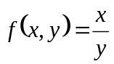
b) Write down the criteria of maxima and minima of three independent variables
c) Solve e^{x-y} dx + e^{y-x} dy = 0
d) 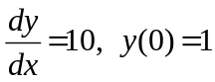
e) Bernouli's equation of differential equation.
Nepal College of Information Technology
Unit Test
Spring 2011
Program : BE IT/ELX Time : 2 hrs
Semester : Fall (II) FM : 70
Subject : Engineering Math-II PM : 35

- Candidates are requested to give their answer as far as practicable in their own words.
- The figure in the margin indicates the full marks
- Attempt ALL question

1. a) Solve:
(x+y)² y' = a² [7]
b) Solve:
2xy dy = (x²+y²) dx, y(1) = 2 [8]
2. a) Solve [7]
b) Solve y" - 3y' +2y = 4x +e^{x} [8]
3. Solve the following differential equation
a) y" - y' - 2y = 3e^{2x} y(0) = 0, y'(0) = -2 [8]
b) y" + 2y' +y = 4e^{-x} logx [7]
4. a) State and prove Enler's theorem on homogeneous function of two independent variables and if
[8]
b) Prove that of all the rectangular parallelopipeds of given surface, cube has the maximum volume. [7]
5. Attempt the following [2*5]
a) Verify Euler's theorem for
b) Write down the criteria of maxima and minima of three independent variables
c) Solve e^{x-y} dx + e^{y-x} dy = 0
d)
e) Bernouli's equation of differential equation.

